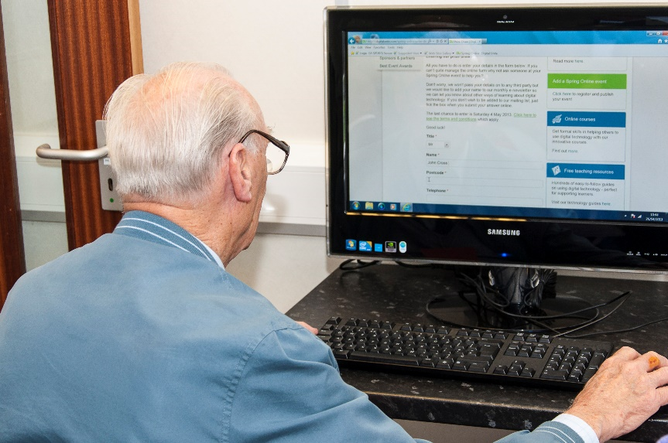

|  |  |  |
| --- | --- | --- |
|  | |  |
|  | **This is to certify that:**   |  | | --- | |  |   **Has completed the**  **Sharing Digital Skills training module**   |  | | --- | | They have:   * **Gained an understanding** of the benefits and barriers to getting online. * **Learnt how to confidently assist beginners and intermediate digital learners**. * **Gained practical skills teaching and communication skills** that will help them to patiently teach and inspire learners to progress with their digital skills.   Signed: Dated: | | |
|  | |  |
|  | |
|  | |  |
|  | |  |
|  | |  |
|  | |  |

A drawing of a person

Description generated with high confidence